**EXERCISE 8 REACTJS-HOL**

**OBJECTIVES:**

**React State** refers to a built-in object in React components that allows components to store and manage data that may change over time. State determines how a component behaves and what it renders on the UI. When the state of a component changes, React automatically re-renders the component to reflect the updated data, ensuring that the UI stays in sync with the application’s data.

Unlike **props**, which are passed from parent to child components and are read-only, **state is mutable** and is managed within the component itself. State can hold values like numbers, strings, arrays, objects, or even other components.

In functional components, state is typically managed using the useState Hook, while in class components, state is managed using this.state and updated with this.setState().

**HANDSON EXERCISE:**

**STRUCTURE:**

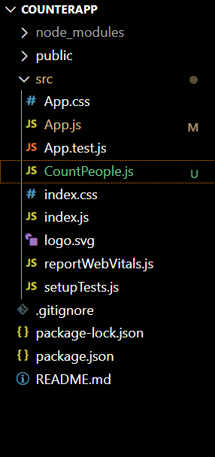

**CODE:**

**App.js**

import React from 'react';

import CountPeople from './CountPeople';

function App() {

  return (

    <div className="App">

      <CountPeople />

    </div>

  );

}

export default App;

**CountPeople.js**

import React, { Component } from 'react';

class CountPeople extends Component {

  constructor() {

    super();

    this.state = {

      entrycount: 0,

      exitcount: 0

    };

  }

  updateEntry = () => {

    this.setState((prevState) => ({

      entrycount: prevState.entrycount + 1

    }));

  }

  updateExit = () => {

    this.setState((prevState) => ({

      exitcount: prevState.exitcount + 1

    }));

  }

  render() {

    return (

      <div style={styles.wrapper}>

        <div style={styles.section}>

          <button style={styles.button} onClick={this.updateEntry}>Login</button>

          <span style={styles.text}>{this.state.entrycount} People Entered!!!</span>

        </div>

        <div style={styles.section}>

          <button style={styles.button} onClick={this.updateExit}>Exit</button>

          <span style={styles.text}>{this.state.exitcount} People Left!!!</span>

        </div>

      </div>

    );

  }

}

const styles = {

  wrapper: {

    display: 'flex',

    justifyContent: 'space-around',

    marginTop: '100px',

    fontFamily: 'Arial',

  },

  section: {

    display: 'flex',

    alignItems: 'center',

    gap: '10px',

  },

  button: {

    backgroundColor: 'green',

    color: 'white',

    padding: '8px 16px',

    border: '1px solid black',

    borderRadius: '4px',

    cursor: 'pointer',

    fontWeight: 'bold'

  },

  text: {

    fontSize: '18px',

    color: '#333'

  }

};

export default CountPeople;

**OUTPUT:**

